NECTARIA
User Manual V1

Contents
1. Introduction to Nectaria
2. Navigating the Nectaria Interface
3. The Interview Tool
4. The Deal Assistant (Hestia)
5. The Policy Assistant (Clio)
6. General Tips for Using Nectaria
7. Advanced Features

1. Introduction to Nectaria
Nectaria is an AI agent tool built for Yellow Brick Road brokers, designed to help them work more efficiently and effectively. It brings together three core AI agents to help with every stage of a deal, from policy searches and client recordings to updating deal information through to settlement.

1.1 The Three Core Agents

Policy Assistant
The Policy Assistant indexes policy documents from every lender on the YBR panel with documentation on file. Brokers can search across all policies to explore the best lenders for scenarios and current deals, as well as question a specific lender’s policy in depth.

Interview Tool
The Interview Tool lets brokers record or upload customer conversations. It automatically extracts key facts to be mapped into a deal assistant and offers call feedback and suggestions for further opportunities, such as asset finance. The extracted fields are identical to the fields you’ll see in YNet.

Deal Assistant
The Deal Assistant is where brokers can manage every stage of the client’s deal from lead to settlement. It allows brokers to build on a deal by continually adding new information and conversations. It integrates any conversations you’ve had with the policy assistant about a deal and ensures you never miss a task at every stage of the deal process.

2. Navigating the Nectaria Interface
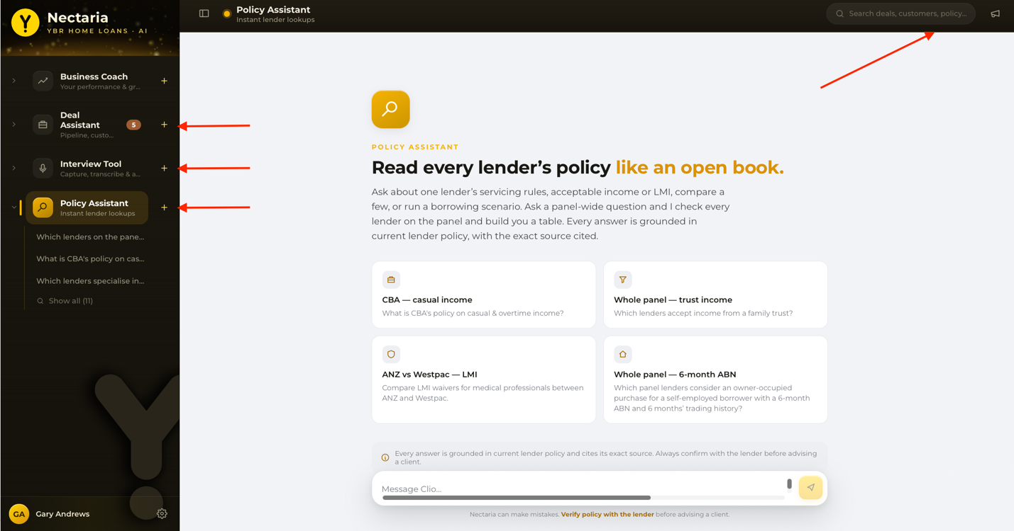
All three agents, Policy Assistant, Interview Tool, and Deal Assistant, are accessible from the sidebar on the left side of the screen.

2.1 Left Sidebar
- Each agent can be expanded to show your recent conversation history with that agent.
- A “+” button lets you start a new conversation with any agent directly from the sidebar.
- A settings menu at the bottom of the sidebar holds "Your profile" (section 7.1), "Archived" (section 7.7), the terms of use, and Log out.

2.2 Top Right
- Search across all of your previous conversations.
- The “?” icon opens the help menu. It has three items:
  - Help AI Agent — ask questions about how to use Nectaria and get an answer on the spot.
  - Help Docs — opens this manual inside Nectaria.
  - Feedback & help requests — send feedback to the Nectaria team, or ask them for help.
- Section 7.2 covers the help menu in more detail.

3. The Interview Tool
Use the Interview Tool to capture conversations with customers and automatically extract the key facts you need to progress their deal.

3.1 Getting Started
- Click into the Interview Tool from the left sidebar.
- You'll land on a page showing all your recent interviews. Click through any of these to review past sessions.
- To start a new interview, click the red button in the top right of the page labelled “+ New Interview Session” to begin.
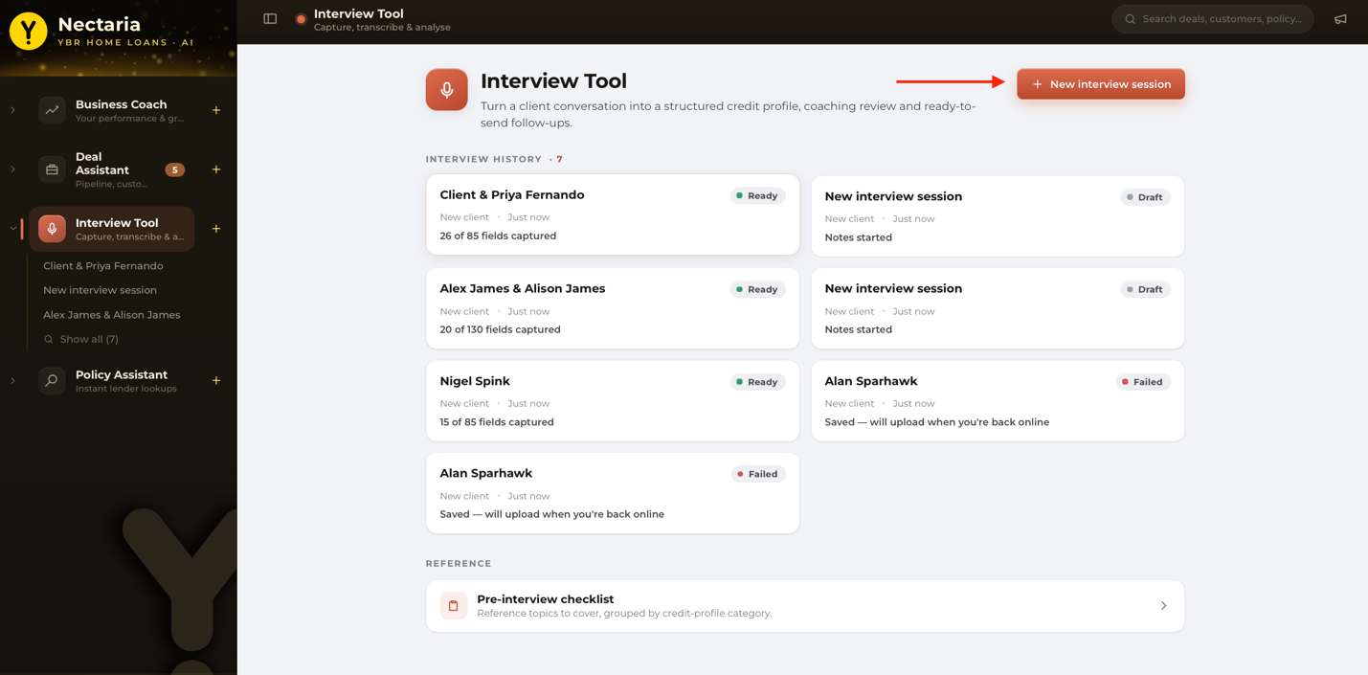

3.2 Preparing for an Interview
Once you start a new interview session, name it — typically after your client's name. The session page provides several guides to help you run a more effective interview. These can be very helpful as part of the training process for new or less confident brokers.
- A conversational guide covering:
  - Conversation openings
  - Agenda statement to explain to the client what you’ll cover
  - Questions to help you explore the client's current situation
  - Questions to help you understand the client’s desired situation
- Checklist for all the areas of information the tool will try to extract from the conversation. You can expand each item to see what information to gather, and tick items off as you confirm them.
- Notes is a free-text area for capturing information that isn’t explicitly covered elsewhere. You don’t need to use this for every interview, but it can help ensure Nectaria doesn’t miss key information if you don’t cover it on the call.

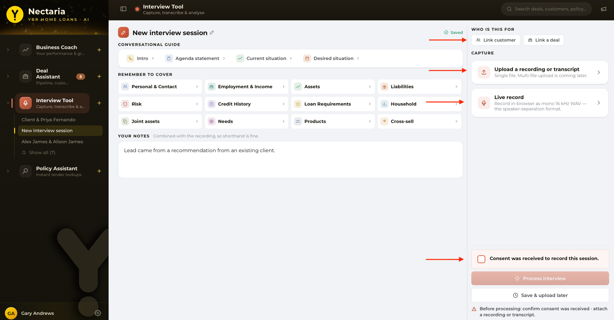

3.3 Recording an Interview
On the right-hand side of the new interview session screen:
- Link an existing customer — if you're meeting a returning customer, select them from the list.
- Link a deal — if the customer already has a deal, select the associated deal.
There are three ways to capture the interview itself:
- Upload an audio file — if you've recorded the conversation on your laptop or phone, upload the audio file.
- Upload a transcript — if the meeting ran on Teams, Zoom, or Google Meet, export the transcript and upload it here.
- Live recording — record the conversation directly if the customer is with you now, on mobile or desktop. The first time you record, you may be asked to grant microphone access — approve this to continue.
For both uploads and recordings, Nectaria won’t allow you to continue unless you tick the consent button to confirm the client has consented to have the interview recorded.

3.4 Reviewing the Transcript
After processing, Nectaria returns a transcript that identifies all speakers so you can see who shared what information.
- If something is wrong (for example, an incorrect date of birth), you can type a correction as a note — this will be merged into the extracted record at the next step, or you can merge it manually later.
- Once reviewed, click Extract fields to build the client profile.

3.5 Extracted Interview Details
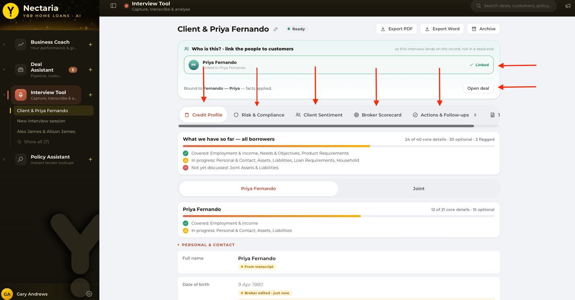
After extraction, you’ll be presented with details from the call. You can also link the call to an existing deal or open a new deal. Both will take you to the Deal Assistant.
You will also see several menu items: Credit Profile, Risk and Compliance, Client Sentiment, Broker Scorecard, and Actions and Follow-ups.
These tabs are not just a report to read. Several of them are editable — you can correct extracted values, resolve conflicts between your notes and the transcript, answer the compliance checks, and edit the actions. Section 7.4 covers this in detail.

Credit Profile
This tab shows how many of the core credit profile details have been completed and flags areas still needing coverage, such as assets or liabilities.
- Each individual party (e.g. both applicants on a joint application) has their own set of details — name, date of birth, income, and so on.
- A joint view shows combined details relevant to both parties together, such as loan purpose, target property, and price.
You can also manually edit any of the client details in the Credit Profile.
The credit profile is the full picture of information the borrower has shared and is used to inform the deal assistant. The fields also map to those used in YNet.

Risk and Compliance
This tab surfaces concerns or risks that a broker should manage throughout the lending process — for example, flagging limited financial experience so the broker can address a knowledge gap, or noting that the customer doesn't have a will so the broker can recommend they get one.
Use this tab to identify further compliance-related questions to address with the customer. You can answer each item Yes or No, and add a mitigation note against it. The answers and notes appear on the deal once a linked interview has been reconciled.

Client Sentiment
Nectaria analyses the conversation and extracts the client's sentiment, highlighting both positive signals (e.g., the customer has already completed 20 property inspections) and areas of concern (e.g., affordability concerns). This gives a broker a read on how likely the deal is to progress, along with suggested coaching to help move a cautious client toward a more positive engagement.

Broker Scorecard
This tab assesses how effectively the broker ran the conversation:
- Talk-time ratio — brokers should aim for roughly 40% talking / 60% listening.
- Checklist coverage — the percentage of checklist questions covered in the conversation (e.g. 86%).
- Cross-sell opportunities flag those opportunities already covered on the call and products not yet raised. For example, if a client mentions they have vehicle finance, but it isn’t addressed as an opportunity on the call, Nectaria will highlight it.
- Style observations — for example, whether the broker asked open versus closed questions, set expectations clearly, and discussed risk appropriately.
- A summary of strengths to keep building on, and suggestions for improvement.
Reviewed over time and across many interviews, the scorecard is designed to help brokers build stronger client conversations.

Actions and Follow-ups
This tab pulls out recommended next actions based on the conversation and creates a follow-up email to send to the client.
These actions will also carry forward into the Deal Assistant.
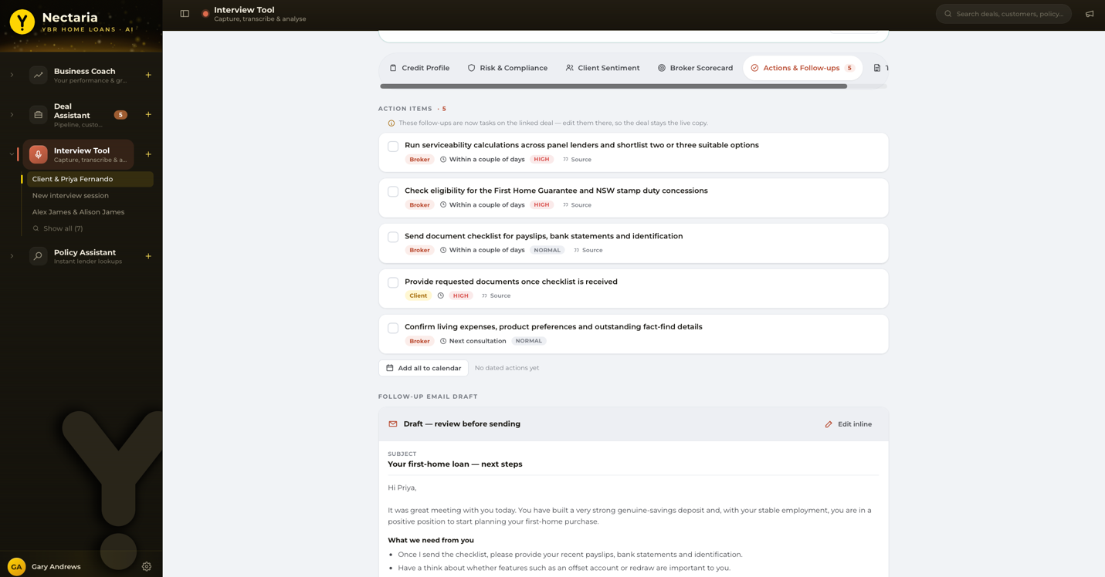
Recommended steps at this stage:
- Review each action and delete anything unnecessary.
- Edit actions as needed: change the task name, add a due date, or set a priority.
- Where a due date/time is set, you can save the action to your calendar. Click the calendar icon to generate a single .ics file to upload into your calendar.
- Nectaria also drafts a follow-up email summarising the interview and next steps, which you can edit in Nectaria to add your own voice, add more actions, and check the signature. You can download it as an .eml file that’s compatible with most email clients or copy it to your clipboard to paste into a client email.

4. The Deal Assistant aka Hestia
Once you've reviewed an interview, you can create a deal from it, which takes you into the Deal Assistant.
The interview tool will take you directly into an individual deal. Clicking the Deal Assistant in the left-hand column will show all deals.
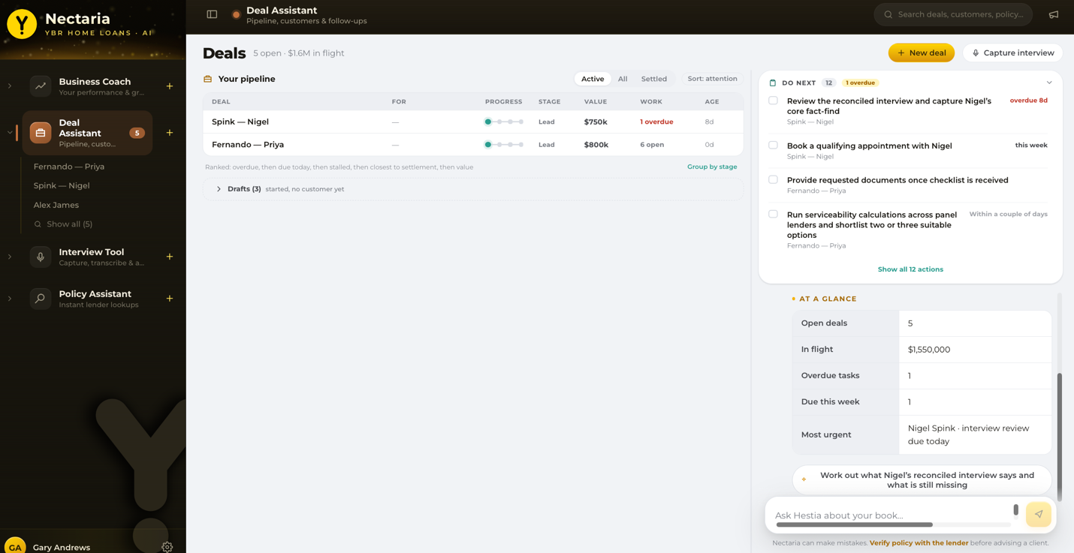

4.1 Overview
Hestia brings together the information gathered from interviews and ongoing conversations, so you're equipped to drive the deal forward from lead through to settlement.
You can converse with Hestia and query any part of the client’s scenario.
At any time, you can feed Hestia new or updated information from the client. Hestia will be able to automatically update this in the client’s profile.

4.2 Tasks
Recommended tasks (for example, “contact the customer” or “book the initial fact-find appointment”) can be added from Hestia's summary. All tasks appear in a list on the right, sorted by due date and relative urgency.

4.3 Notes
Below the task section, you can add free-text notes.

4.4 Activity Feed
The activity feed lists everything related to the deal — facts that have been established, plus the ability to jump back into the source interview each fact came from.

4.5 Adding Interviews, Tasks & Parties
From the deal screen you can:
- Record a new interview with the customer.
- Add a task manually.
- Bind an interview — if you've already run a separate interview, connect it to this existing deal.
- Add another party — if you've spoken with someone else associated with the deal, add them here. A party can be an applicant, a co-applicant or a guarantor.

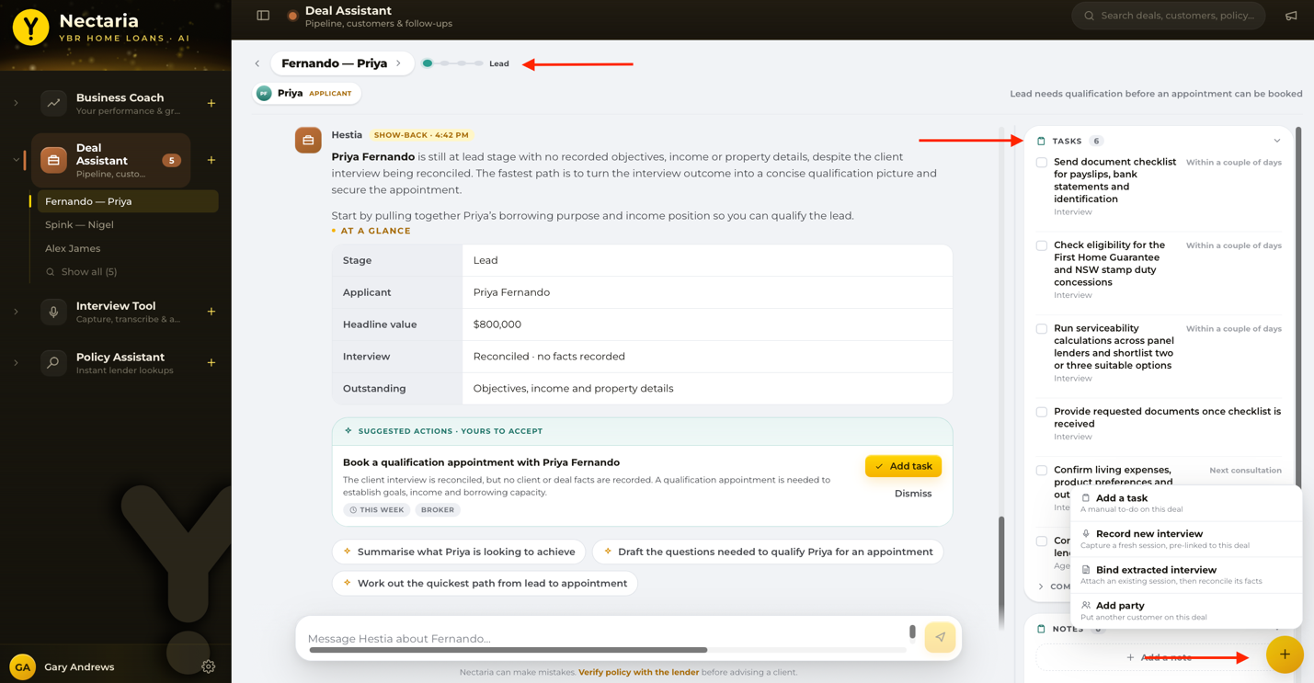

4.6 Deal Status
Next to the deal name at the top of the screen is a status dial showing the deal's current stage. Click forward to move the deal through its stages:
- Lead
- Appointment
- Lodged
- Settled
Hestia tailors its guidance and recommendations based on which stage the deal is currently at.
You can also click into the deal name to see all details from the deal or click into an individual applicant's name to see the details specific to that individual.

4.7 Chatting with Hestia
The chat panel is where Hestia's value comes through most directly. You can update Hestia with new information as you learn it — for example, when a customer's income changes — and Hestia will add it as a new fact on the deal, with the option to confirm the update.
Hestia can also help you:
- Draft a follow-up email to the customer (e.g. requesting updated payslips).
- Build an agenda for an upcoming conversation.
- Recommend the next best action to progress the deal, based on all information and actions currently on file.

4.8 Sending to the Policy Assistant
Once you've built up a rich data set for a customer through interviews and conversations, you can send that information from the Deal Assistant to the Policy Assistant. This is always an automatic prompt suggestion at the bottom of the chat.
When you ask to compare all lenders from the Deal Assistant, Hestia will create a pre-populated prompt for the Policy Assistant. You can add extra details to this.
Policy Assistant then scans the full lender panel for that scenario. You can ask the Policy Assistant follow-up questions (see section 5 for how to use the Policy Assistant)
You can then return to the deal, where Hestia now has the context of that policy exploration and will attach it to the client profile.

5. The Policy Assistant aka Clio

5.1 Overview
Clio has access to all policy documents from all lenders on the Yellow Brick Road panel.
You can search across a specific lender or the whole panel, and converse with Clio much like any other AI chat tool.
Note: Clio can only answer based on what a lender has actually documented and provided to YBR. If a lender's documentation is incomplete on a topic, Clio won't be able to fill that gap. In this instance, contact your BDM.

5.2 Two Ways to Ask a Question
There are two main types of questions you can ask Clio:
- Panel-wide questions, such as which lenders meet a specific customer requirement (e.g. “which lenders accept income from a family trust?”).
Asking a question phrased this way (“which lenders…”, “how many lenders…”, or any panel-wide question) automatically triggers a full scan across every lender with documentation on file.
- Specific lender questions — what a named lender's policy says on a particular topic (e.g. “what is Commonwealth Bank's policy on casual and overtime income?”).

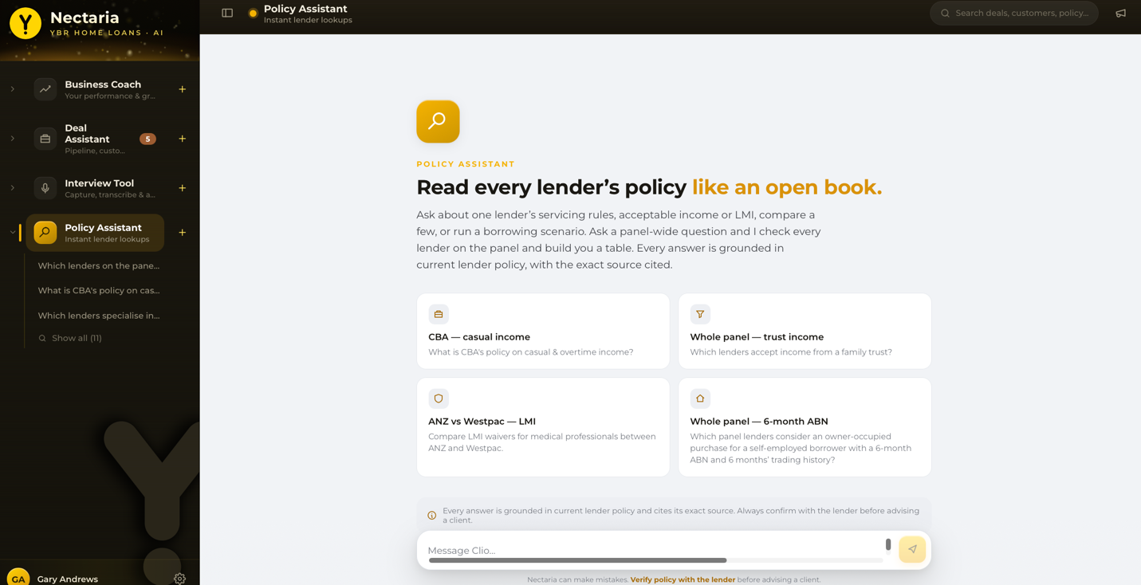

Panel-wide Scans
Once a panel scan finishes, you can expand a lender-by-lender comparison table showing each lender's answer to your question. Below the table, Clio provides a written summary:
- The first paragraph gives Clio's best recommendations — the lenders that most closely match the customer's needs.
- Further paragraphs group lenders by common themes in their answers.
If you don't yet have the answer you need, keep asking questions.
Clio will often suggest useful follow-up questions directly or you can type your own follow-up. A useful general follow-up is asking Clio to summarise only the “yes” answers from the scan.

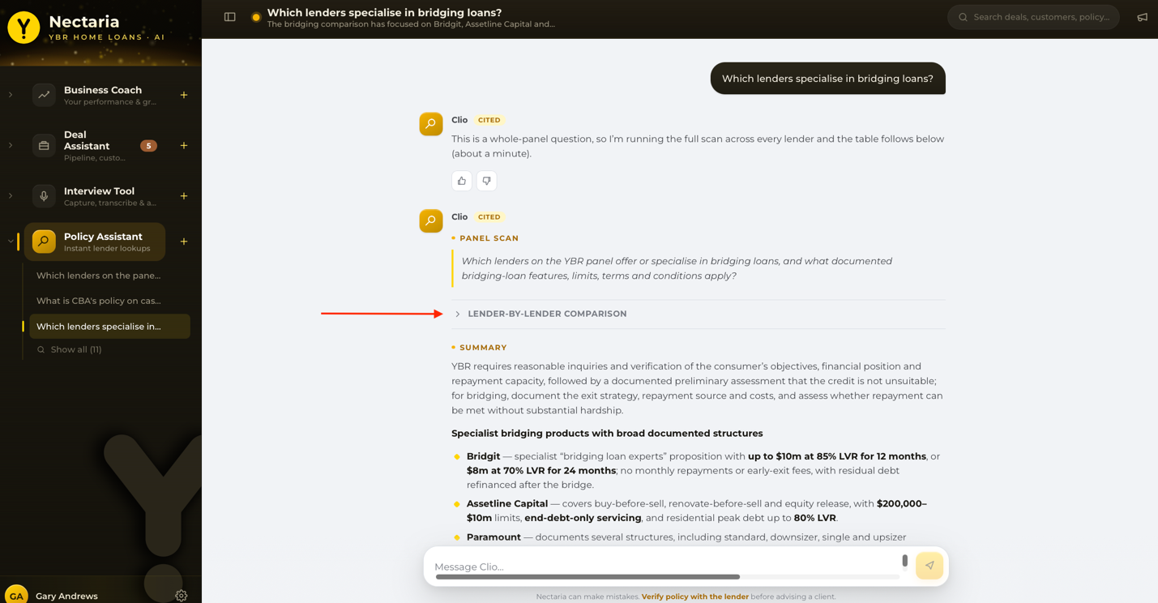

Specific Lender Questions
Ask Clio directly about a named lender's policy on a topic, and it will search that lender's documentation.
Nectaria was partly inspired by YBR's existing Ask an Advisor service. If you're unsure about a policy question, try Clio first to see whether it can answer before emailing Ask an Advisor.

6. General Tips for Using Nectaria
- Treat every agent as a conversation, not a single-shot search. Asking follow-up questions consistently produces better answers than accepting the first response.
- When in doubt about an answer, ask for its source or evidence — this applies especially to the Policy Assistant, where citing the source document is the fastest way to verify an answer.
- The more detail you provide, the better the result — this holds across all three agents.
- Use the Interview Tool's checklist as a live guide during the conversation, not just a post-hoc review tool.
- Don't forget the “+” button inside a deal — it's the way to add another party, bind an existing interview, or add a task manually, and it's easy to miss.

7. Advanced Features
This section covers the features brokers most often miss. Everything here sits alongside the everyday use described in sections 3 to 5.

7.1 Your Profile
You can teach Nectaria things about the way you work, so you don’t have to repeat yourself in every conversation.
- Tell an assistant to remember something durable — a preference, a lending focus, a goal — and it will offer the fact back to you as a card.
- The card has a “Save” button. Saving is what keeps the fact, and the card then reads “Saved”. If you dismiss it instead, the card reads “Dismissed” and nothing is kept.
- This works in the Policy Assistant and the Deal Assistant, both inside a deal and in the book-level chat on the Deal Assistant landing page.
- Saved facts are shared across every assistant, so you only need to tell Nectaria once.
To see what Nectaria has saved, open “Your profile” from the settings menu in the left sidebar. From there you can:
- Edit a value inline.
- Remove a fact you no longer want Nectaria to use.
- Add a fact by hand, with a label and a value.

7.2 The Help Menu
The “?” icon in the top right of the screen opens the help menu. It has three items.

Help AI Agent
Ask questions about how to use Nectaria and get an answer without leaving the screen you’re on.
- The help agent answers from this manual. If something isn’t covered here, it won’t be able to help you with it — use Feedback & help requests instead.
- The help conversation is not saved. Closing the panel discards it, so copy anything you want to keep.

Help Docs
Opens this manual inside Nectaria.

Feedback & help requests
Send feedback straight to the Nectaria team. This is also how you ask the team for help when the help agent and the docs couldn’t answer your question.

7.3 Getting More Out of a Conversation

Conversation summary
Click the conversation title in the top bar to read a rolling summary of the whole conversation. It is built as replies arrive rather than worked out when you open it, so it is current the moment you look.

Rating an answer
Every answer has a thumbs up and a thumbs down, and you can add a comment as well. This is the main way brokers improve the agents, so it is worth using when an answer is unusually good or clearly wrong.

Search
Search sits in the top right and covers your interview sessions as well as your conversations.
- Before you type there is a Recent / All toggle.
- Below it, each source you have content in gets its own chip. Switch any combination of them on or off — you are not limited to one.
- Opening search from a section’s “Show all” pre-filters it to that source.

Collapsing the sidebar
The sidebar can be collapsed to icons to give the working area more room. This helps on a smaller screen.

7.4 Advanced Use of the Interview Tool

Capture
- You can drag and drop a file onto the capture panel instead of browsing for it.
- Use the Audio / Transcript toggle to tell Nectaria which kind of file you are giving it.
- Audio: .mp3, .mp4, .m4a, .wav and .ogg, up to 200MB.
- Transcript: .vtt, .srt and .txt, up to 2MB.
- One file per session.
- The file is checked for type and size when you pick it, so a wrong file is refused straight away with a reason rather than failing later.
- Nectaria doesn’t allow you to drop a folder of files into the transcription, only one file may be uploaded.

Save & upload later
If your connection is poor, you don’t have to upload straight away.
- “Save & upload later” parks the recording on your device.
- The session reappears in Interview History on the Interview Tool landing page, marked “Saved — will upload when you’re back online”. Open it and the capture panel is waiting for you.
- A session that already has a transcript reopens at its output rather than back at capture, so nothing you have already done is overwritten.
- A session that failed is recoverable in the same way. It is not a dead end.

Session statuses
Every session on the Interview Tool landing page carries a status.
- Draft — you have created it but not sent it for processing. Your notes, consent tick and any links are saved.
- Processing — Nectaria is working through it: uploading, transcribing, extracting, then reviewing. If it says queued, the recording is waiting for a better connection and will upload on its own.
- Ready — the transcript is back, and normally the extracted details with it.
- Failed — a processing attempt did not complete. Nothing is lost; open the session and try again.

Notes and sign-in
- Notes autosave as you type. The “Saved” indicator only appears once the note really has been saved — if a save fails it says so and offers a retry rather than claiming success.
- If your sign-in times out mid-interview you will see “Your sign-in session has timed out. Nothing here is lost”, with a link to open Nectaria in a new tab. Sign in there, come back, and carry on.

Linking customers and deals
- You can link up to four people to one session. At the cap the add control is disabled and reads “This session already has 4 people on it.”
- That cap is on who you link. It does not limit the interview itself — Nectaria still works out the real number of borrowers from the transcript.
- You can bind an open deal to the session from the session page.
- Once a session is bound to a deal, the deal owns its actions. The Actions tab stops offering edits it could not carry through, which is expected rather than a fault.

Managing a session
- Rename a session by clicking its name and typing over it.
- “Export PDF” and “Export Word” download the extracted output for your file notes or for CRM entry. The export happens on your own machine — nothing is uploaded.
- “Archive” takes two clicks. The first turns the control into “Confirm archive” and “Cancel”. See section 7.7.
- Each output tab has its own feedback prompt, separate from the thumbs on chat answers. It is the way to tell the team when an extraction was wrong.

Extracting is a One-time Step
“Extract fields” is available once, while the session has a transcript but no extracted profile yet. After it runs the button is gone. There is no re-extract, so nothing you correct by hand can be overwritten later.
That is why the order matters. Type corrections as notes before you extract and Nectaria merges them in. After extracting, edit the fields directly in the Credit Profile.

Credit Profile in Depth
- Where your notes disagree with the transcript, Nectaria shows a conflict card rather than quietly picking one. The two sides are labelled “From your notes” and “From transcript”.
- Choose the side that is right, or use the box marked “…or enter the correct value” and press Save.
- “Mark N/A” is for a field that genuinely does not apply. An “Undo” control appears on the field if you mark the wrong one.
- “To be confirmed” is for something you have agreed to confirm with the customer later. The field comes out of the missing count and is not counted against your completeness, without anything being made up.
- Where the AI was not certain of a value it leaves a “Confidence note” explaining why.
- “Transcript excerpt” under a field shows the words the value came from, so you can check the source without leaving the tab.
- Completeness is shown per borrower and across all borrowers together. The states are:
  - Covered — the topic was discussed and captured.
  - In progress — partly covered, with information still outstanding.
  - Not yet discussed — the topic did not come up.

The Two Completeness Figures
- The history card shows what the extraction captured — for example “26 of 65 fields captured”. It is a record of what came off the call and does not change afterwards. The total varies by session, because it depends on how many people are on it and which fields were relevant.
- The bar at the top of the Credit Profile shows where the profile stands now and moves as you fill fields in. It counts core details only, and lists optional, N/A and flagged fields separately, so completing an optional field does not inflate the score.
- The two figures differing once you have done some editing is expected.

Risk & Compliance in Depth
- Each item can be answered Yes or No.
- You can add a mitigation note against an item.
- The answers and notes appear on the deal once a linked interview has been reconciled. Until then the deal shows “No risk answers on record yet. They appear here once a linked interview is reconciled.”

Client Sentiment in Depth
- “Moment-level highlights” picks out individual points in the conversation. Each carries a “Read:” line — Nectaria’s plain summary of what it took from that moment.
- “Broker guidance” suggests how to move a cautious client toward a more positive position.

Broker Scorecard
The scorecard assesses how the conversation itself was run. It has five parts.
- Talk-time ratio — your share of the talking against the client’s, with the benchmark of roughly 40 broker / 60 client shown underneath, and a short note on what the split means for this particular conversation.
- Question completeness — an overall percentage, then each area of the credit profile with its own status. The legend is:
  - Captured — the area was covered in the conversation.
  - Incomplete — partly covered, with information still outstanding.
  - Not covered — the area did not come up.
  - Agreed follow-up — you and the customer agreed to come back to it later.
- Cross-sell coverage — each opportunity with a one-line note and a status: Discussed, Missed, or N/A where it does not apply to this customer.
- Style observations — short verdicts on how you handled things such as open versus closed questions, risk framing and expectation setting.
  - “Advanced coaching — tone, empathy & pacing” appears on this card marked SOON. It is not available yet.
- Summary — Strengths to keep building on, and Suggestions for your next conversation.

Actions in Depth
- You can edit a task’s name, date, time and priority.
- The calendar icon on an action is “Add to calendar (.ics)”. Below the list, “Add all to calendar” does the whole set at once.
- The drafted email summarises the interview and lists the next steps. You can edit it inline to add your own voice, adjust the actions, and check the signature. Your edit is kept, so what you download matches what you see.
- “Download .eml” opens it in your email client. “Copy to clipboard” (which flips to “Copied”) lets you paste it into a message yourself.

Searching the Transcript
You can search within the transcript to jump straight to the moment something was said.

Pre-interview Checklist
The Interview Tool landing page has a checklist marked “Static v1 reference · printable”. There is no print button — print it from your browser if you would rather work from paper during the meeting.

7.5 Advanced Use of the Deal Assistant (Hestia)

Asking About Your Whole Book
From the Deal Assistant landing page — before you open any single deal — the composer reads “Ask Hestia about your book…”. Use it as a briefing at the start of the day: what is moving, what has stalled, and where your attention is needed.
- The book chat is a briefing only. You cannot create tasks or hand off to the Policy Assistant from there — both need a specific deal.
- Inside a deal, Hestia answers about that deal only.

Do Next
- “Do next” rolls up the urgent work across every one of your deals into a single list.
- Ticking an item there completes it on the deal as well. It is the same task in both places, not a copy.
- The list is a straight sort of your real tasks, not an AI selection, so it is right the moment anything changes.

Suggested Actions
- Hestia suggests actions as you work. The button is “Add task” — nothing exists on the deal until you click it.
- “Dismiss” clears a suggestion you do not need.

Confirming a Fact
When you tell Hestia something new in chat, it proposes the fact rather than writing it straight in. It arrives on the same kind of card as a profile fact, with a “Save” button, and the saved fact lands on the deal’s fact record.

Reconcile
Reconcile is how an interview’s facts are walked into a deal.
- You can work through it guided, card by card, or as a full list.
- Until you do, the deal shows the session as “bound but not yet reconciled” with a count of fields that “need you”. Those are the ones where the interview says something different from what is already on the deal, and Nectaria will not choose for you.
- Once you have been through it the deal is marked “Reconciled”. That means the interview’s facts have been dealt with, not that every one of them was accepted.

The Client Record
The client record shows one customer across all of their deals and interviews. Use it when a customer has more than one deal on the go, or when you want their history in one place.

Pipeline Controls
- Filter your deals by Active, All or Settled.
- “Sort: attention” is a single button that cycles. Click it to step through attention, then value, then age.
- “Group by stage” arranges the pipeline by stage; the same control then reads “Ungroup”.
- A deal started blank, with no parties attached, is a draft. Drafts collapse out of the pipeline into their own group headed “Drafts” with a count, which you can expand.

Resizing the Rail
The right-hand rail can be resized by dragging its edge, so you can give more room to either the chat or to your tasks and activity. Nectaria remembers the width you chose for next time.

7.6 Advanced Use of the Policy Assistant (Clio)

When a Single-lender Question Is Really a Panel Question
Sometimes a question about one lender is really a question about the whole panel. If Clio spots that, it says so in its reply and runs the full panel scan itself. You do not need to re-ask the question. The scan takes about a minute.

The Record Left on a Deal
After you explore policy for a deal, a record of that exploration is left on the deal so the work is not lost. Its summary keeps updating as the Clio conversation continues, so coming back to the deal later shows you where the exploration got to, not just where it started.

7.7 Archiving
Archiving is how you move finished work out of the way without deleting it.
- You can archive a deal, a customer, an interview or a Policy Assistant conversation.
- Archived records are hidden from your lists and from search. They are not deleted — the control says so: “Archive — hidden from lists & search, record kept, restorable”.
- Open “Archived” from the settings menu in the sidebar to see them. It opens inside the Deal Assistant.
- Hestia conversations that belong to a deal do not appear in Archived. They go with the deal, so archive the deal instead.
- You can restore an archived record at any time.
- Restore works one record at a time. Restoring a deal does not automatically restore its customers, interviews and conversations — you will need to restore each of those yourself.

7.8 When Something Goes Wrong
These are the messages that might be encountered:

The microphone is blocked
You will see “Microphone access was blocked. Allow the microphone in your browser, then try again.” Nectaria cannot unblock it for you. Allow the microphone in your browser’s own site settings, then start the recording again.

A file was refused
The message names the reason: either the wrong kind of file for the Audio / Transcript toggle you are on, or one over the size limit. The formats and limits are in 7.4.

Processing failed
The session is not lost. Open it from Interview History — your notes, consent, coverage and any deal link are all still there, and you can attach the recording again. If the session already has a transcript it reopens at the extracted output rather than back at capture.

The transcript came back but the details did not
If the transcript succeeded and only the extraction failed, the session stays at Ready and shows an error rather than moving to Failed. That is correct — the transcript is real and worth keeping. The extracted details cannot be produced from that session afterwards, so run a fresh session if you need them, and raise it through Feedback & help requests.

Your sign-in timed out mid-interview
You will see “Your sign-in session has timed out. Nothing here is lost”, with a link to open Nectaria in a new tab. Sign in there, come back, and continue.

A page says the feature is not available
That means it is not switched on for your account, not that anything is broken. Send it through Feedback & help requests.

A section is empty when you expected data
Nectaria shows an honest empty state rather than filling the space with sample figures. An empty panel means there is nothing on record yet, not that the number is zero.

