|  |  |
| --- | --- |
| Sales & Referral Planner | 2014 |

My sales & referral planning guide to assist my business focus on the result I would like in 2014

***The past year in review:***

Results for 2013 were:

|  |  |  |  |  |
| --- | --- | --- | --- | --- |
| No of loans submitted |  | Volume | $ | My Income from Loans in 2013 was |
| No of loans declined |  | Volume | $ |  |
| No of loans approved |  | Volume | $ |  |
| No of loans settled |  | Volume | $ | Upfront $  New Trail $  Existing Trail $ |
| Conversion rate – submitted to settlement % | % |  |  |  |
|  |  |  |  |  |
| No of customer first interviews |  |  |  |  |
| No of leads my business received |  |  |  |  |

***Referrals & other Products & Services sold:***

|  |  |  |  |
| --- | --- | --- | --- |
| Referrals to | Number | No of Sales Successes | Additional Revenues in 2012 |
| Vow Wealth |  |  | $ |
| Vow Leasing |  |  | $ |
| Vow Legal |  |  | $ |
| Vow Commercial |  |  | $ |
| Allianz – GI |  |  | $ |
| Vow Property – Blue Wealth/ APP / Future Estate |  |  | $ |
| Other Direct sales / Referrals of my own relationships |  |  | $ |

*My expenses in 2013 were $*

***Main Challenges in 2013***

|  |
| --- |
| What were the issues that impacted on your business where you did not achieve your desired results last year: |

***Achievements in 2013***

|  |
| --- |
| List your major achievements during the year – major clients won/ large sales /referral successes / advocates of your business/ client retentions etc. |

*2014 – the year ahead*

|  |
| --- |
| What are the key business drivers for your business this year: ( client retention, marketing activities, targeted market/s, key things to do to improve your incomes/profits |

What are the challenges this year?

|  |
| --- |
| What do you need to keep an eye on?: competitors, compliance, expenses etc. |

*My desired income for this year 2014 is?*

|  |  |  |
| --- | --- | --- |
| Upfront |  | $ |
| Trail | Existing Trail PA is $ +  new trails $ | $ |
| Referrals |  | $ |
| Other sales |  | $ |
| Gross Income |  | $ |
| *Less*  Expenses (approx.) |  | $ |
| NPBT |  | $ |

*What do I have to do to achieve this?*

**Example:**

If your average loan size is say $400K & you use 50/50 lenders who pay trail in the first year

(say your existing loan trail book income per mth is $3K) plus ongoing non mortgage mthly referral revenues are say $350 per mth) = $40K p.a.

If you want a basic income of say $60K plus my existing trail $40K p.a. to make $100K then your loan activity needs to be:

25 settlements @ $400K = $10M @ Avg. .6% upfront = $60K

If your interview to settlement ratio is 4:1 then you need at least 2 interviews/ leads a week to achieve your desired income levels ( don’t; forget to allow for some holidays so best to work on an 11mth year, so 3 interviews a week should be your goal.

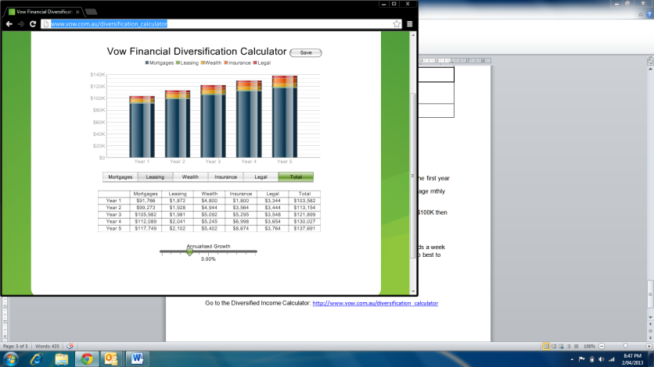***What extra income could I have with a successful referral program?***

Go to the Diversified Income Calculator: <http://www.vow.com.au/diversification_calculator>